**Write a python program to perform the following -**

**1. read and write operations on a file:-**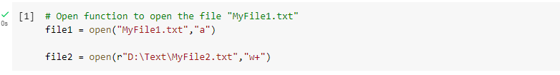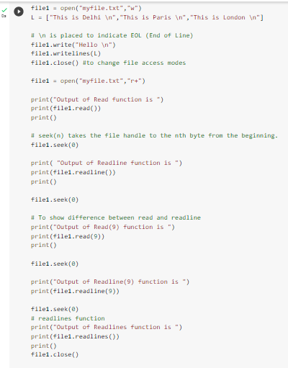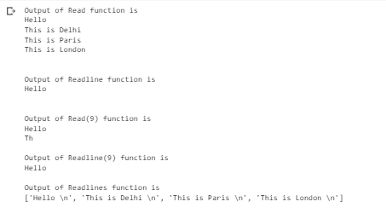

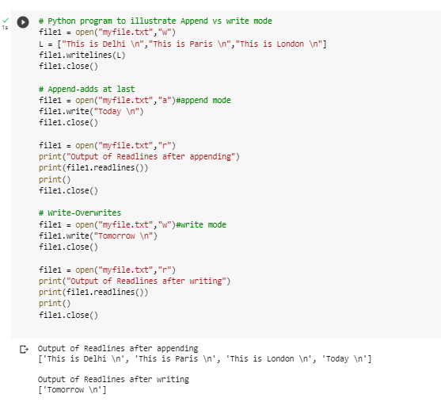

**2. copy the contents of a file to another**

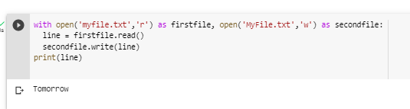

**3. count frequency of characters in a given file.**

